**Instructions: Please read carefully**

* Submit the file before **11:59pm on 21/10/2020** in your **github repository** in **Lab task 1 folder. If you cannot complete the full task, do not worry. Just upload what you have completed.**
* **You must upload a screenshot of each task also**
* You can take help from your class mate or internet but don’t copy from them. Its important for you to learn

|  |
| --- |
| **1. Create a HTML structure for the following layout:** |
| **2. Create a HTML structure for any of your personal interest (e.g. Your CV/Personal website/Movie character/Cartoon character/Sportsman)** |

<!DOCTYPE html>

<html lang="en">

<head>

    <meta charset="UTF-8" />

    <meta name="viewport" content="width=device-width, initial-scale=1.0" />

    <meta http-equiv="X-UA-Compatible" content="ie=edge" />

    <title>Lab-1-Task</title>

    <link rel="stylesheet" href="style.css">

</head>

<body>

    <div align="center">

        <p><span>*</span>- Denotes Required Information</p>

        <p><b>> 1 Donation&nbsp; &nbsp; &nbsp; </b> > 2 Confirmation &nbsp; &nbsp;&nbsp;> Thank You!</p>

        <form action="loginSubmitted.php" method="post">

            <table>

                <tr>

                    <td>

                        <h3>Donor Information</h3>

                    </td>

                    <td></td>

                </tr>

                <tr>

                    <td>First name:<span>*</span></td>

                    <td><input name="fName" type="text" /></td>

                </tr>

                <tr>

                    <td>Last name:<span>*</span></td>

                    <td><input name="lName" type="text" /></td>

                </tr>

                <tr>

                    <td>Address 01:<span>*</span></td>

                    <td><input name="add1" type="text" /></td>

                </tr>

                <tr>

                    <td>Address 02:<span>*</span></td>

                    <td><input name="add2" type="text" /></td>

                </tr>

                <tr>

                    <td>City:<span>*</span></td>

                    <td><input name="city" type="text" /></td>

                </tr>

                <tr>

                    <td>State:<span>*</span></td>

                    <td>

                        <select name="state">

                            <option value="" selected> Select a state</option>

                            <option value="Dhaka"> Dhaka</option>

                            <option value="Kalkata"> Kalkata</option>

                            <option value="London"> London</option>

                        </select>

                    </td>

                </tr>

                <tr>

                    <td>Zip code:<span>*</span></td>

                    <td><input name="zip" type="number" /></td>

                </tr>

                <tr>

                    <td>Country:<span>*</span></td>

                    <td>

                        <select name="country">

                            <option value="" selected> Select a Country</option>

                            <option value="BD"> BD</option>

                            <option value="INDIA"> INDIA</option>

                            <option value="UK"> UK</option>

                        </select>

                    </td>

                </tr>

                <tr>

                    <td>Phone:</td>

                    <td><input name="phone" type="number" /></td>

                </tr>

                <tr>

                    <td>Fax:</td>

                    <td><input name="fax" type="text" /></td>

                </tr>

                <tr>

                    <td>Email:<span>*</span></td>

                    <td><input name="email" type="email" /></td>

                </tr>

                <tr>

                    <td>Donation Amount:<span>*</span></td>

                    <td>

                        <input type="radio" vlaue="" name="amount" checked /> None

                        <input type="radio" vlaue="50" name="amount" /> $50

                        <input type="radio" vlaue="75" name="amount" /> $75

                        <input type="radio" vlaue="100" name="amount" /> $100

                        <input type="radio" vlaue="250" name="amount" /> $250

                        <input type="radio" vlaue="other" name="amount" /> Other

                    </td>

                </tr>

                <tr>

                    <td><small>(Check a button or type in your amount)value

                            value

                            value</small></td>

                    <td><b>Other Amount $</b> <input name="customAmount" type="number" /></td>

                </tr>

                <tr>

                    <td><b>Recurring Donation</b></td>

                    <td>

                        <input name="monthlyBasis" type="checkbox" /> I am interested in giving on a regular

                        basis.

                    </td>

                </tr>

                <tr>

                    <td><small>(Check if yes)</small></td>

                </tr>

                <tr>

                    <td></td>

                    <td>

                        Monthly Credit Card $ <input name="perMonthAmount" type="text" /> For

                        <input name="forMonths" type="text" /> Months

                    </td>

                </tr>

                <tr>

                    <td>

                        <h3>

                            Honorarium and Memorial Donation Information

                        </h3>

                    </td>

                    <td></td>

                </tr>

                <tr>

                    <td><b>I would like to make this donation</b></td>

                    <td>

                        <input type="radio" name="donation" /> To Honor <br />

                        <input type="radio" name="donation" /> In Memory Of

                    </td>

                </tr>

                <tr>

                    <td><b>Name:</b></td>

                    <td>

                        <input name="donarName" type="text" />

                    </td>

                </tr>

                <tr>

                    <td><b>Acknoledge Donation to:</b></td>

                    <td>

                        <input name="donationTo" type="text" />

                    </td>

                </tr>

                <tr>

                    <td><b>Address:</b></td>

                    <td>

                        <input name="donarAddress" type="text" />

                    </td>

                </tr>

                <tr>

                    <td><b>City:</b></td>

                    <td>

                        <input name="donarCity" type="text" />

                    </td>

                </tr>

                <tr>

                    <td>State:</td>

                    <td>

                        <select name="donarState">

                            <option selected> Select a state</option>

                            <option value="Dhaka"> Dhaka</option>

                            <option value="Kalkata"> Kalkata</option>

                            <option value="London"> London</option>

                        </select>

                    </td>

                </tr>

                <tr>

                    <td>Zip</td>

                    <td>

                        <input name="donarZip" type="text" />

                    </td>

                </tr>

                <tr>

                    <td>

                        <h3>Additional Information</h3>

                    </td>

                    <td></td>

                </tr>

                <tr>

                    <td style="text-align: left;">

                        <small>

                            Please Enter your name, company or organization as you would like

                            it to appear in our publications:</small>

                    </td>

                </tr>

                <tr>

                    <td><b>Name</b></td>

                    <td>

                        <input name="addName" type="text" />

                    </td>

                </tr>

                <tr>

                    <td style="text-align: left;">

                        <input name="giftCheck" type="checkbox" /> I would like my gift to remain anonymous.

                        <br />

                        <input name="offerCheck" type="checkbox" /> My employer offers a matching gift

                        program. I will mail the matching gift form. <br />

                        <input name="costCheck" type="checkbox" /> please save the cost of acknowledging this

                        gift by not mailing a thank you letter. <br />

                    </td>

                    <td></td>

                </tr>

                <tr>

                    <td>

                        <b>Comments</b><br />

                        <small>(Please type any question or feedback here)</small>

                    </td>

                    <td>

                        <textarea name="comment" cols="35" rows="5"></textarea>

                    </td>

                </tr>

                <tr>

                    <td><b>How may we contact you?</b></td>

                    <td>

                        <input name="offers[]" value="e-mail" type="checkbox" /> E-Mail <br />

                        <input name="offers[]" value="post-mail" type="checkbox" /> Post Mail <br />

                        <input name="offers[]" value="telephone" type="checkbox" /> Telephone <br />

                        <input name="offers[]" value="fax" type="checkbox" /> Fax <br />

                    </td>

                </tr>

                <tr>

                    <td>

                        <small>

                            I would like to recieve newsletters and information about special

                            events by:</small>

                    </td>

                </tr>

                <tr>

                    <td></td>

                    <td>

                        <input name="offeres[]" value="emailNewsletter" type="checkbox" /> E-Mail <br />

                        <input name="offeres[]" value="postMailNewsLetter" type="checkbox" /> Post Mail <br />

                    </td>

                </tr>

                <tr>

                    <td style="text-align: left;">

                        <input name="volunteerCheck" type="checkbox" /> I would like information about

                        volunteering with the Organization

                    </td>

                </tr>

                <tr>

                    <td>

                        <input type="button" value="Reset" />

                    </td>

                    <td>

                        <input type="submit" value="Submit" />

                    </td>

                </tr>

                <tr>

                    <td style="text-align: left;">

                        <small>Donate online with confidence. You are on a secure server</small>

                    </td>

                </tr>

                <tr>

                    <td style="text-align: left;">

                        <small>If you have any problems or questions, please contact

                            support.</small>

                    </td>

                </tr>

            </table>

        </form>

    </div>

</body>

</html>

Style.css file

h3 {

    color: red;

    text-align: left;

}

tr>td:nth-child(1) {

    text-align: right;

    font-weight: bold;

}

tr>td>small {

    font-weight: 100;

}

span {

    color: red;

}

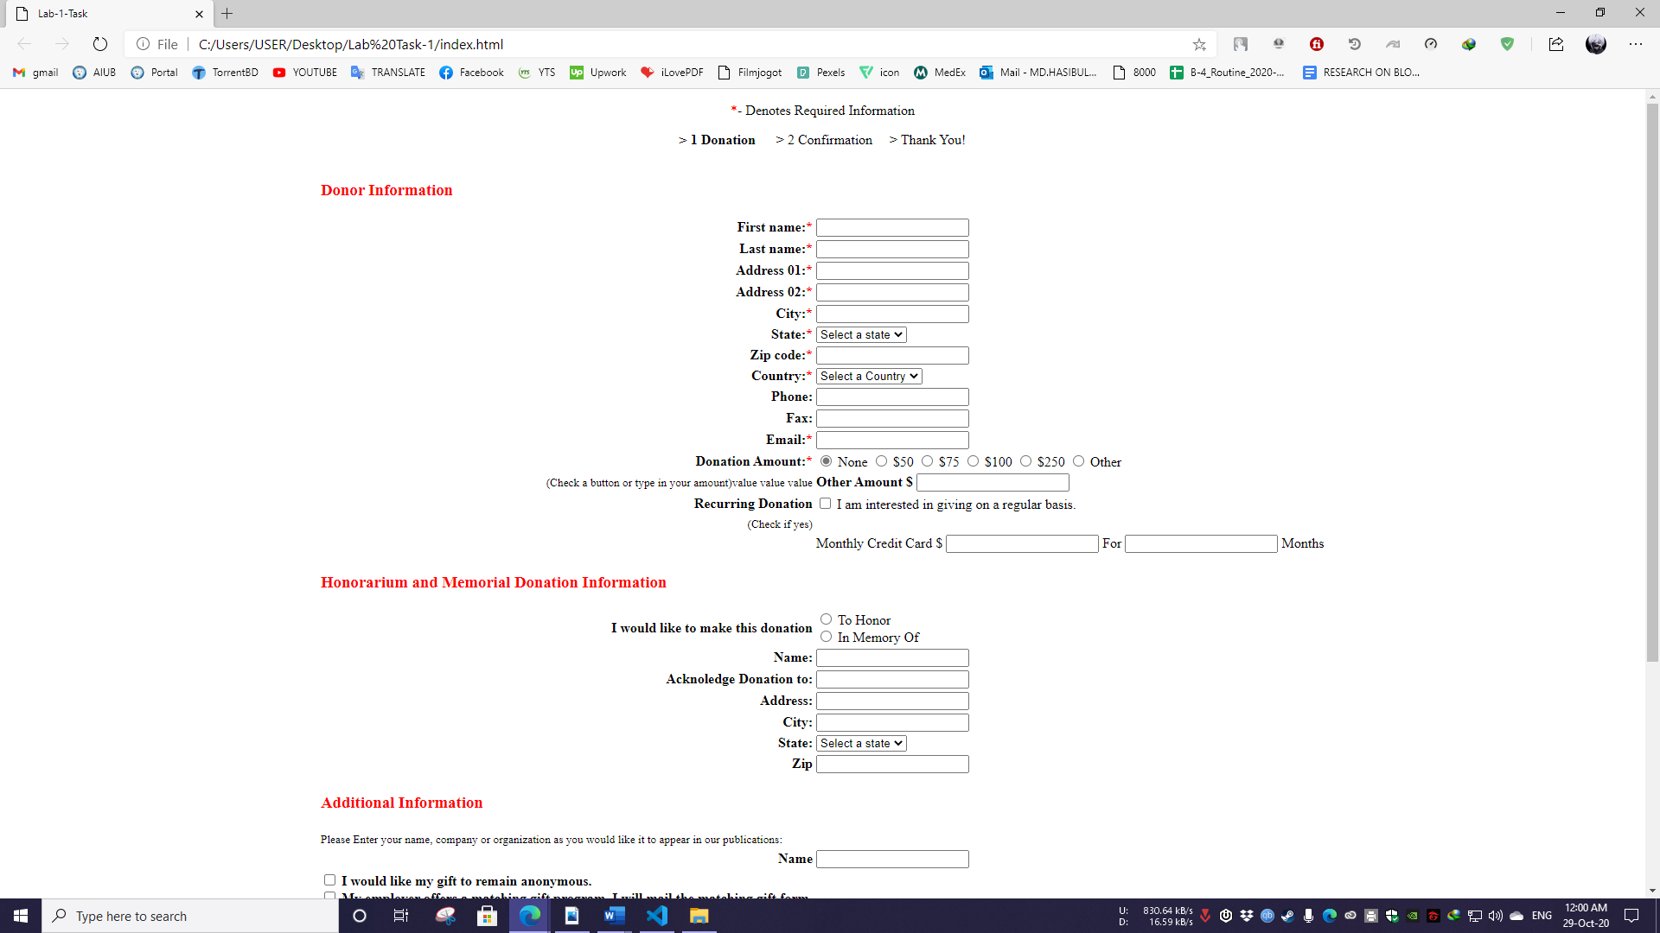

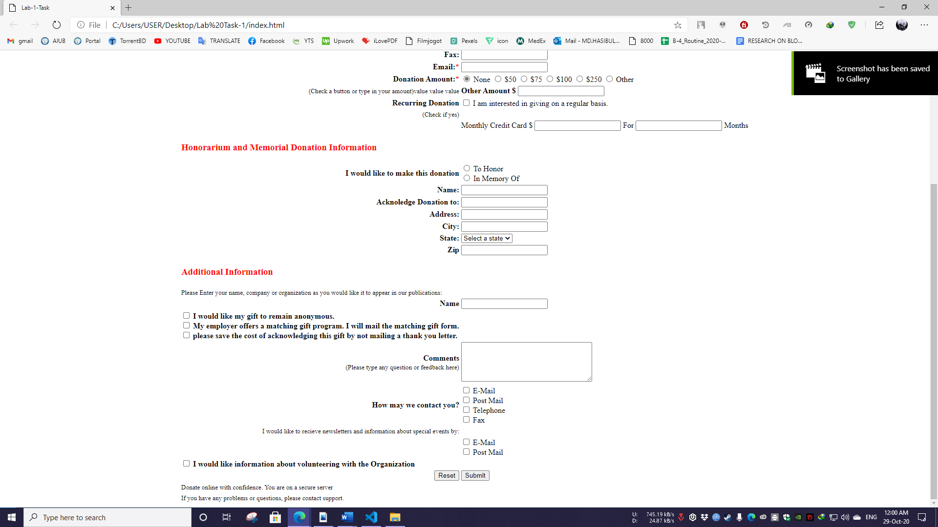

**Create a HTML structure for any of your personal interest (e.g. Your CV/Personal website/Movie character/Cartoon character/Sportsman):**

* Create a HTML codes :
  + Insert the HTML code in the given spaces Insert the code output (the screenshots) from the browser in the given spaces.

<html>

  <body>

    <form>

        <div align="center">

            <h1>Registration</h1>

                <table>

                    <tr>

                        <td>Name:</td>

                        <td><input type="text" value="Ria"></td>

                    </tr>

                    <tr>

                        <td>Username:</td>

                        <td><input type="text" value=""></td>

                    </tr>

                    <tr>

                        <td>password:</td>

                        <td><input type="password" value=""></td>

                    </tr>

                    <tr>

                        <td>Gender:</td>

                        <td><input type="radio" name="gender" value="">Male<br><input name="gender" type="radio" value="">Female</td>

                    </tr>

                    <tr>

                        <td>Hobbies:</td>

                        <td><input type="checkbox" value="">Movies<br><input type="checkbox" value="">Games <br><input type="checkbox" value="">Music</td>

                    </tr>

                    <tr>

                        <td>Profession:</td>

                        <td><select name="" id="">

                            <option value="">Teacher</option>

                            <option value="">Student</option>

                            <option value="">Govt Job</option>

                        </select></td>

                    </tr>

                    <tr>

                        <td></td>

                        <td><input type="submit" value="Submit"></td>

                    </tr>

                </table>

        </div>

    </form>

  </body>

</html>

